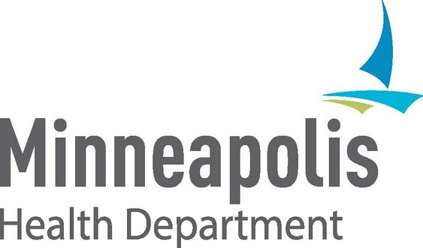

PROTECTING KIDS AND SCHOOLS FROM COVID-19

The first day of school is just around the corner!

Children 12 years and older are able to get the Pfizer COVID-19 vaccine. Consider vaccinating your eligible children for a safe return to school.

Vaccination is protection!



The COVID-19 vaccine can prevent your child from getting and spreading the virus.

If your child gets COVID-19, the vaccine

could prevent them from becoming severely ill.



Clinical trials for Pfizer vaccine have proven to be safe and effective for children 12 and older.

The vaccine doesn't contain the live virus and does not cause

infertility.

Fully vaccinated people have greater protection against the Delta variant. This variant spreads very quickly and causes more severe COVID-19 among those who are unvaccinated.

FULL VACCINATION TAKES 5 WEEKS

VACCINATE YOUR CHILD BEFORE THE FIRST DAY OF SCHOOL

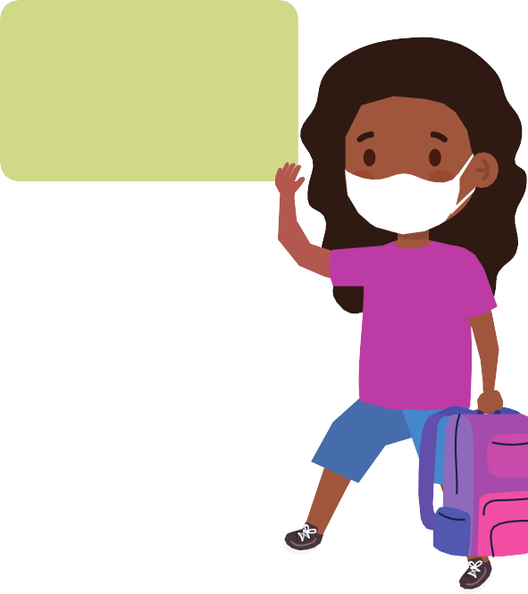



First Dose: By August 2

To find a COVID-19 vaccine clinic:

Talk to your child’s pediatrician or check with your local pharmacy. Visit [www.tinyurl.com/mplsvax](http://www.tinyurl.com/mplsvax) or [www.mn.gov/covid19/vaccine](http://www.mn.gov/covid19/vaccine/find-vaccine)

Fully vaccinated child by the first day of school



Second Dose: By August 23